**Syllabus:** Image Segmentation

**UNIT - V**

Detection of discontinuous, edge linking and boundary detection, thresholding, region–based segmentation

**Introduction**

* Segmentation is to subdivide an image into its component regions or objects.
* Segmentation should stop when the objects of interest in an application have been isolated.
* Segmentation algorithms generally are based on one of 2 basis properties of intensity values:

**Discontinuity**: to partition an image based on sharp changes in intensity

**Similarity**: to partition an image into regions that are similar according to a set of predefined criteria.

* A more formal definition – Let R represent the entire image region. We may view segmentation as a process that partitions R into n sub regions, R1, R2..., Rn, such that

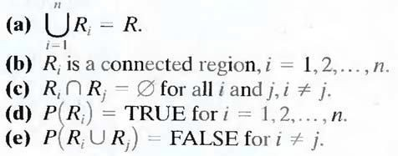

* Here, P (Ri) is a logical predicate defined over the points in set Ri and Ǿ`

is the null set. Condition

* (a) Indicates that the segmentation must be complete; that is, every pixel must be in a region. Condition
* (b) Requires that points in a region must be connected in some predefined sense. Condition
* (c) Indicates that the regions must be disjoint. Condition
* (d) Deals with the properties that must be satisfied by the pixels in a segmented region—for example P (Ri) = TRUE if all pixels in Ri, have the same gray level.
* Finally, condition (e) indicates that regions Ri and Rj are different in the sense of predicate P.
  + 1. **Detection of discontinuities**
* In this we present several techniques for detecting the three basic types of gray level discontinuities in a digital image: points, lines and edges.
* The most common way to look for discontinuities is to run a mask through the image. The 3X3 mask shown in following figure.
* This procedure involves computing the sum of products of the coefficients with the gray levels contained in the region encompassed by the mask.
* The response of the mask at any point in the image is given by

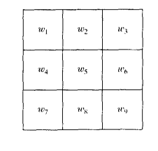

* Where Zi is the gray level of the pixel associated with mask coefficient Wi.
* The response of the mask is defined with respect to its centre location

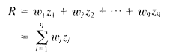

**Point Detection:**

* The detection of isolated points in an image is straight forward in principle. Using the mask shown in figure:6.2(a),we say that a point has been detected at the location on which the mask is cantered if |R|>=T
* Where T is a non negative threshold and R is given by equation 6.1- 1.Basically this formulation measures the weighted differences between the centre point and its neighbours .The idea is an isolated point will be quite different from its surroundings and thus be wisely detectable by this type of mask.0

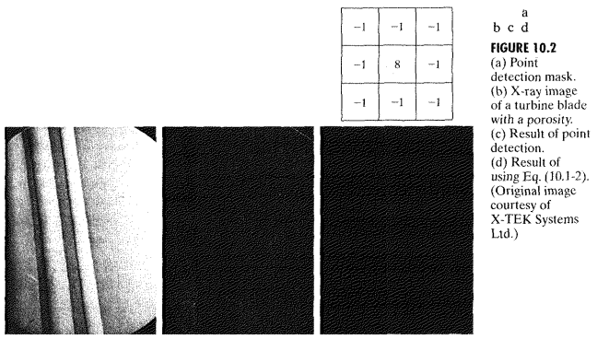

**Line Detection:**

* The next level of complexity is line detection. consider the masks shown in figure 6.3.If the first mask were moved around an image ,it would respond more strongly to lines(1 pixel thick)oriented horizontally .With a constant background ,the maximum response would result when he line passed through the middle row of the mask.
* This is easily verified by sketching a simple array of 1’s with a line of a different gray level (say 5s)running horizontally through the array .A similar experiment would reveal that the second mask in following figure response best to lines oriented at +45 degrees.
* The third mask to the vertical lines, and the fourth mask to lines in the -

45 degrees direction. These directions can be establish also by noting that the preferred direction of each mask is waited with a larger co- efficient (i.e. 2) than other possible directions.

* Note that the coefficients in each mask sum to 0, indicating a zero response from the masks in areas of constant gray level.

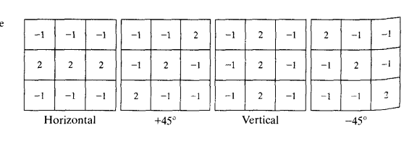

* Let R1,R2,R3, and R4 denote the responses of the masks in the above figure, from left to right, suppose that 4 masks are run individually through an image. If at a certain point in image,

that point is said to be more likely associated with a line in the direction of mask i.

* For example, if at a point in the image for j=2,3,4 that particular point is said to be more likely associated with a horizontal line.
* Alternatively, we may be interested in detecting lines in a specified direction. In this case, we would use the mask associated with that direction and threshold its output.
* In the following figure 10.4(a) shows a digitized (binary) portion of a wire

– bond mask for an electronic circuit. Suppose that we are interested in finding all the lines that are one pixel thick and are oriented at -450. For this purpose we use the last mask shown in the above figure. The absolute value of the result is shown in the figure 10.4(b).

* Note that all vertical and horizontal components of the image were eliminated, and that the components of the original image that tend towards a -450 direction produced the strongest response. In order to determine which lines best fit the mask, we simply threshold this image. The result of using a threshold equal to the maximum value in the image is shown in figure 10.4(c).

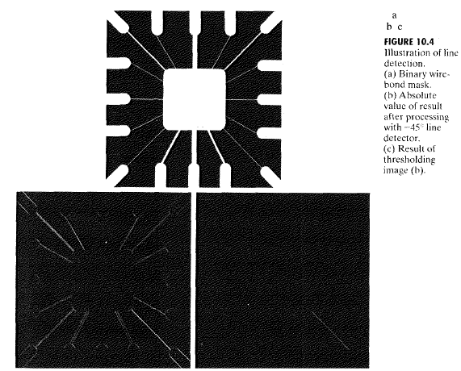

**Edge detection:**

* Intuitively, an edge is a set of connected pixels that lie on the boundary between two regions. Fundamentally, an edge is a "local" concept whereas a region boundary, owing to the way it is defined, is a more global idea. A reasonable definition of "edge" requires the ability to measure gray-level transitions in a meaningful way. We start by modeling an edge intuitively. This will lead us to formalism in which "meaningful" transitions in gray levels can be measured.
* Intuitively, an ideal edge has the properties of the model shown in Fig. 2.1(a). An ideal edge according to this model is a set of connected pixels (in the vertical direction here), each of which is located at an orthogonal step transition in gray level (as shown by the horizontal profile in the figure).
* In practice, optics, sampling, and other image acquisition imperfections yield edges that are blurred, with the degree of blurring being determined by factors such as the quality of the image acquisition system, the sampling rate, and illumination conditions under which the image is acquired. As a result, edges are more closely modeled as having a "ramp like" profile, such as the one shown in Fig.2.1 (b).

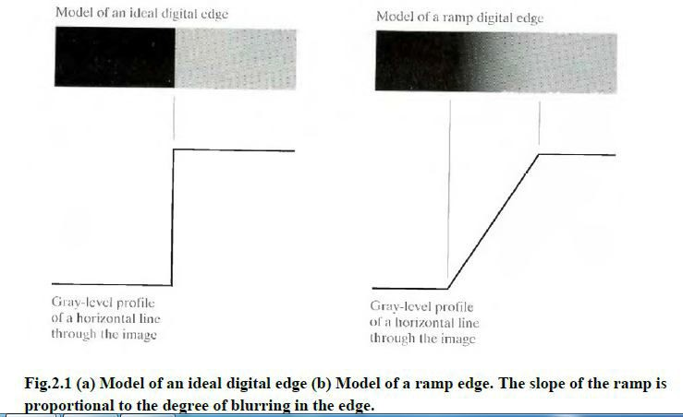

* The slope of the ramp is inversely proportional to the degree of blurring in the edge. In this model, we no longer have a thin (one pixel thick) path. Instead, an edge point now is any point contained in the ramp, and an edge would then be a set of such points that are connected. The "thickness" of the edge is determined by the length of the ramp, as it transitions from an initial to a final gray level. This length is determined by the slope, which, in turn, is determined by the degree of blurring. This makes sense: Blurred edges lend to be thick and sharp edges tend to be thin. Figure 2.2(a) shows the image from which the close-up in Fig. 2.1(b)

was extracted. Figure 2.2(b) shows a horizontal gray-level profile of the edge between the two regions. This figure also shows the first and second derivatives of the gray-level profile. The first derivative is positive at the points of transition into and out of the ramp as we move from left to right along the profile; it is constant for points in the ramp; and is zero in areas of constant gray level. The second derivative is positive at the transition associated with the dark side of the edge, negative at the transition associated with the light side of the edge, and zero along the ramp and in areas of constant gray level. The signs of the derivatives in Fig. 2.2(b) would be reversed for an edge that transitions from light to dark.

* We conclude from these observations that the magnitude of the first derivative can be used to detect the presence of an edge at a point in an image (i.e. to determine if a point is on a ramp). Similarly, the sign of the second derivative can be used to determine whether an edge pixel lies on the dark or light side of an edge. We note two additional properties of the second derivative around an edge: A) It produces two values for every edge in an image (an undesirable feature); and B) an imaginary straight line joining the extreme positive and negative values of the second derivative would cross zero near the midpoint of the edge. This zero- crossing property of the second derivative is quite useful for locating the centers of thick edges.

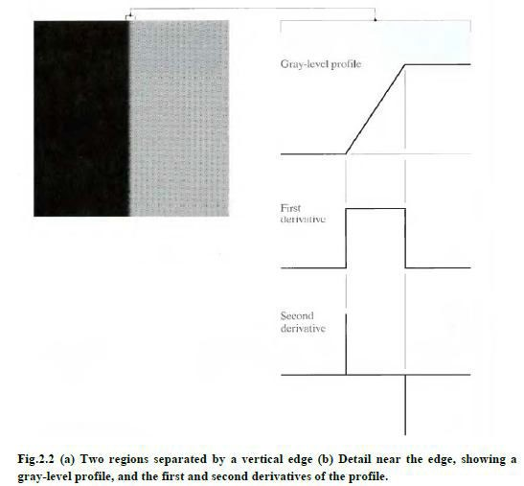

**Gradient operators:**

* First-order derivatives of a digital image are based on various approximations of the 2-D gradient. The gradient of an image f (x, y) at location (x, y) is defined as the vector

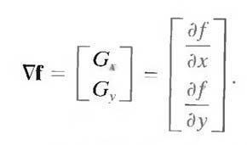

* It is well known from vector analysis that the gradient vector points in the direction of maximum rate of change of f at coordinates (x, y). An important quantity in edge detection is the magnitude of this vector, denoted by , where



* This quantity gives the maximum rate of increase of f (x, y) per unit distance in the direction of . It is a common (although not strictly correct) practice to refer to also as the gradient. The direction of the gradient vector also is an important quantity. Let α (x, y) represent the direction angle of the vector at (x, y). Then, from vector analysis,

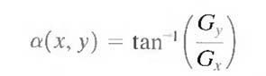

* Where the angle is measured with respect to the x-axis. The direction of an edge at (x, y) is perpendicular to the direction of the gradient vector at that point. Computation of the gradient of an image is based on obtaining the partial derivatives ฀f/฀x and ฀f/฀y at every pixel location. Let the 3x3 area shown in Fig. 1.1 (a) represent the gray levels in a neighborhood of an image.One of the simplest ways to implement a first-order partial derivative at point z5 is to use the following Roberts cross-gradient operators:

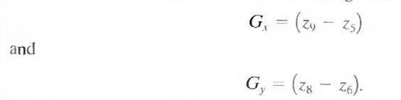

* These derivatives can be implemented for an entire image by using the masks shown in Fig. 1.1(b). Masks of size 2 X 2 are awkward to implement because they do not have a clear center. An approach using masks of size 3 X 3 is given by

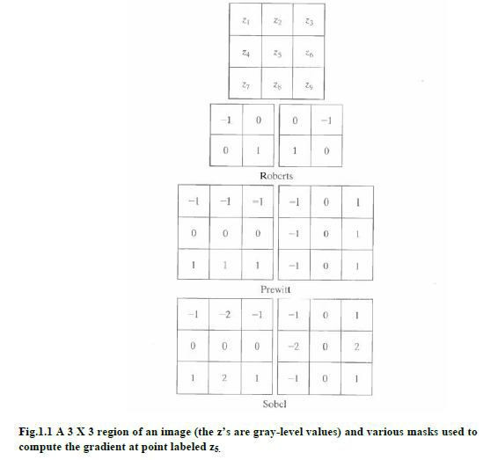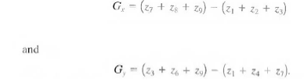

* A weight value of 2 is used to achieve some smoothing by giving more importance to the center point. Figures 1.1(f) and (g), called the Sobel operators, and are used to implement these two equations. The Prewitt and Sobel operators are among the most used in practice for computing digital gradients. The Prewitt masks are simpler to implement than the Sobel masks, but the latter have slightly superior noise-suppression characteristics, an important issue when dealing with derivatives. Note that the coefficients in all the masks shown in Fig. 1.1 sum to 0, indicating that they give a response of 0 in areas of constant gray level, as expected of a derivative operator
* The masks just discussed are used to obtain the gradient components Gx and Gy. Computation of the gradient requires that these two components be combined. However, this implementation is not always desirable

because of the computational burden required by squares and square roots. An approach used frequently is to approximate the gradient by absolute values:



* This equation is much more attractive computationally, and it still preserves relative changes in gray levels. However, this is not an issue when masks such as the Prewitt and Sobel masks are used to compute Gx and Gy.
* It is possible to modify the 3 X 3 masks in Fig. 1.1 so that they have their strongest responses along the diagonal directions. The two additional Prewitt and Sobel masks for detecting discontinuities in the diagonal directions are shown in Fig. 1.2.

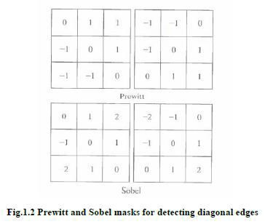

**The Laplacian:**

* The Laplacian of a 2-D function f(x, y) is a second-order derivative defined as

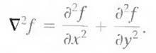

For a 3 X 3 region, one of the two forms encountered most frequently in practice is

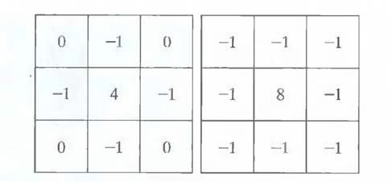

**Fig.1.3 Laplacian masks used to implement Eqns. above.**

* Where the z's are defined in Fig. 1.1(a). A digital approximation including the diagonal neighbors is given by



* Masks for implementing these two equations are shown in Fig. 1.3. We note from these masks that the implementations of Eqns. are isotropic for rotation increments of 90° and 45°, respectively.
  + 1. **Edge linking and Boundary detection**

The different methods for edge linking are as follows

* + - * Local processing
      * Global processing via the Hough Transform
      * Global processing via graph-theoretic techniques.

1. **Local Processing:**

* One of the simplest approaches for linking edge points is to analyze the characteristics of pixels in a small neighborhood (say, 3 X 3 or 5 X 5) about every point (x, y) in an image that has been labeled an edge point. All points that are similar according to a set of predefined criteria are linked, forming an edge of pixels that share those criteria.
* The two principal properties used for establishing similarity of edge pixels in this kind of analysis are (1) the strength of the response of the gradient operator used to produce the edge pixel; and (2) the direction of the gradient vector. The first property is given by the value of .
* Thus an edge pixel with coordinates (xo, yo) in a predefined neighborhood of (x, y), is similar in magnitude to the pixel at (x, y) if



* The direction (angle) of the gradient vector is given by Eq. An edge pixel at (xo, yo) in the predefined neighborhood of (x, y) has an angle similar to the pixel at (x, y) if



* Where A is a nonnegative angle threshold. The direction of the edge at (x,

y) is perpendicular to the direction of the gradient vector at that point. A point in the predefined neighborhood of (x, y) is linked to the pixel at (x,

y) if both magnitude and direction criteria are satisfied. This process is repeated at every location in the image. A record must be kept of linked points as the center of the neighborhood is moved from pixel to pixel. A simple bookkeeping procedure is to assign a different gray level to each set of linked edge pixels.

1. **Global processing via the Hough Transform:**

* In this process, points are linked by determining first if they lie on a curve of specified shape. We now consider global relationships between pixels. Given n points in an image, suppose that we want to find subsets of these points that lie on straight lines. One possible solution is to first

find all lines determined by every pair of points and then find all subsets of points that are close to particular lines. The problem with this procedure is that it involves finding n(n - 1)/2 ~ n2 lines and then performing (n)(n(n - l))/2 ~ n3 comparisons of every point to all lines. This approach is computationally prohibitive in all but the most trivial applications.

* Hough [1962] proposed an alternative approach, commonly referred to as the Hough transform. Consider a point (xi, yi) and the general equation of a straight line in slope-intercept form, yi = a.xi + b. Infinitely many lines pass through (xi, yi) but they all satisfy the equation yi = a.xi + b for varying values of a and b. However, writing this equation as b = -a.xi + yi, and considering the ab-plane (also called parameter space) yields the equation of a single line for a fixed pair (xi, yi). Furthermore, a second point (xj, yj) also has a line in parameter space associated with it, and this line intersects the line associated with (xi, yi) at (a', b'), where a' is the slope and b' the intercept of the line containing both (xi, yi) and (xj, yj) in the xy-plane. In fact, all points contained on this line have lines in parameter space that intersect at (a', b'). Figure 3.1 illustrates these concepts.

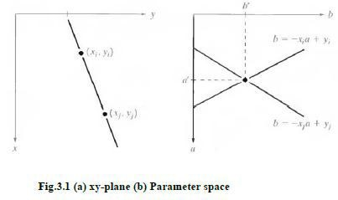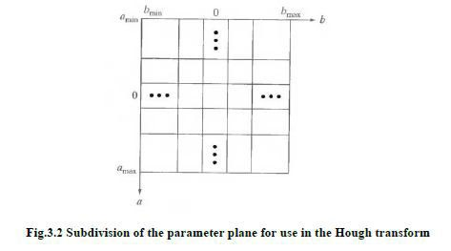

* The computational attractiveness of the Hough transform arises from subdividing the parameter space into so-called accumulator cells, as illustrated in Fig. 3.2, where (amax , amin) and (bmax , bmin), are the expected ranges of slope and intercept values. The cell at coordinates (i, j), with accumulator value A(i, j), corresponds to the square associated with parameter space coordinates (ai , bi).
* Initially, these cells are set to zero. Then, for every point (xk, yk) in the image plane, we let the parameter a equal each of the allowed subdivision values on the fl-axis and solve for the corresponding b using the equation b = - xk a + yk .The resulting b’s are then rounded off to the nearest allowed value in the b-axis. If a choice of ap results in solution bq, we let A (p, q) = A (p, q) + 1. At the end of this procedure, a value of Q in A (i, j) corresponds to Q points in the xyplane lying on the line y = ai x + bj. The number of subdivisions in the ab-plane determines the accuracy of the co linearity of these points. Note that subdividing the a axis into K increments gives, for every point (xk, yk), K values of b corresponding to the K possible values of a. With n image points, this method involves nK computations. Thus the procedure just discussed is linear in n, and the product nK does not approach the number of computations discussed at the beginning unless K approaches or exceeds n.
* A problem with using the equation y = ax + b to represent a line is that the slope approaches infinity as the line approaches the vertical. One way around this difficulty is to use the normal representation of a line: x cosθ + y sinθ = ρ
* Figure 3.3(a) illustrates the geometrical interpretation of the parameters used. The use of this representation in constructing a table of accumulators is identical to the method discussed for the slope-intercept representation. Instead of straight lines, however, the loci are sinusoidal curves in the ρθ -plane. As before, Q collinear points lying on a line x cosθj + y sinθj = ρ, yield Q sinusoidal curves that intersect at (pi, θj) in the parameter space. Incrementing θ and solving for the corresponding p gives Q entries in accumulator A (i, j) associated with the cell determined by (pi, θj). Figure 3.3 (b) illustrates the subdivision of the parameter space

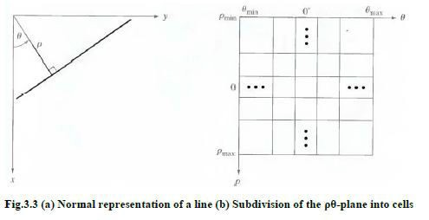

* The range of angle θ is ±90°, measured with respect to the x-axis. Thus with reference to Fig. 3.3 (a), a horizontal line has θ = 0°, with ρ being equal to the positive x-intercept. Similarly, a vertical line has θ = 90°, with p being equal to the positive y-intercept, or θ = - 90°, with ρ being equal to the negative y-intercept.

1. **Global processing via graph-theoretic techniques:**

* In this process we have a global approach for edge detection and linking based on representing edge segments in the form of a graph and searching the graph for low-cost paths that correspond to significant edges. This representation provides a rugged approach that performs well in the presence of noise.

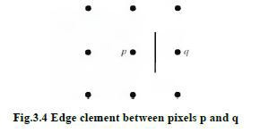

* We begin the development with some basic definitions. A graph G = (N,U) is a finite, nonempty set of nodes N, together with a set U of unordered pairs of distinct elements of N. Each pair (ni, nj) of U is called an arc. A graph in which the arcs are directed is called a directed graph. If an arc is directed from node ni to node nj, then nj is said to be a successor of the parent node ni. The process of identifying the successors of a node is called expansion of the node. In each graph we define levels, such that level 0 consists of a single node, called the start or root node, and the nodes in the last level are called goal nodes. A cost c (ni, nj) can be associated with every arc (ni, nj). A sequence of nodes n1, n2... nk, with each node ni being a successor of node ni-1 is called a path from n1 to nk. The cost of the entire path is

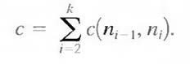

* The following discussion is simplified if we define an edge element as the boundary between two pixels p and q, such that p and q are 4-neighbors, as Fig.3.4 illustrates. Edge elements are identified by the xy-coordinates of points p and q. In other words, the edge element in Fig. 3.4 is defined by the pairs (xp, yp) (xq, yq). Consistent with the definition an edge is a sequence of connected edge elements.
* We can illustrate how the concepts just discussed apply to edge detection using the 3 X 3 image shown in Fig. 3.5 (a). The outer numbers are pixel coordinates and the numbers in brackets represent gray-level values. Each edge element, defined by pixels p and q, has an associated cost, defined as



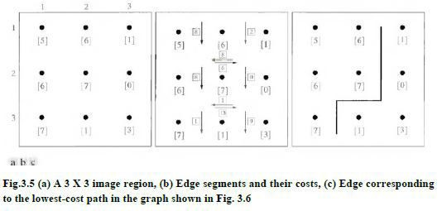

* Where H is the highest gray-level value in the image (7 in this case), and f(p) and f(q) are the gray-level values of p and q, respectively. By convention, the point p is on the right-hand side of the direction of travel along edge elements. For example, the edge segment (1, 2) (2, 2) is between points (1, 2) and (2, 2) in Fig. 3.5 (b). If the direction of travel is to the right, then p is the point with coordinates (2, 2) and q is point with coordinates (1, 2); therefore, c (p, q) = 7 - [7 - 6] = 6. This cost is shown in the box below the edge segment. If, on the other hand, we are traveling to the left between the same two points, then p is point (1, 2) and q is (2, 2). In this case the cost is 8, as shown above the edge segment in Fig. 3.5(b). To simplify the discussion, we assume that edges start in the top row and terminate in the last row, so that the first element of an edge can be only between points (1, 1), (1, 2) or (1, 2), (1, 3). Similarly, the last edge element has to be between points (3, 1), (3, 2) or (3, 2), (3, 3). Keep in mind that p and q are 4-neighbors, as noted earlier. Figure 3.6 shows the graph for this problem. Each node (rectangle) in the graph corresponds to an edge element from Fig. 3.5. An arc exists between two nodes if the two corresponding edge elements taken in succession can be part of an edge.
* As in Fig. 3.5 (b), the cost of each edge segment, is shown in a box on the side of the arc leading into the corresponding node. Goal nodes are shown shaded. The minimum cost path is shown dashed, and the edge corresponding to this path is shown in Fig. 3.5 (c).

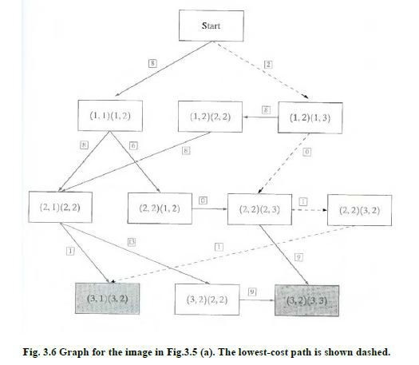

* + 1. **Thresholding**
* Because of its intuitive properties and simplicity of implementation, image thresholding enjoys a central position in applications of image segmentation.

**Global Thresholding:**

* The simplest of all thresholding techniques is to partition the image histogram by using a single global threshold, T. Segmentation is then accomplished by scanning the image pixel by pixel and labeling each pixel as object or back-ground, depending on whether the gray level of that pixel is greater or less than the value of T. As indicated earlier, the success of this method depends entirely on how well the histogram can be partitioned.

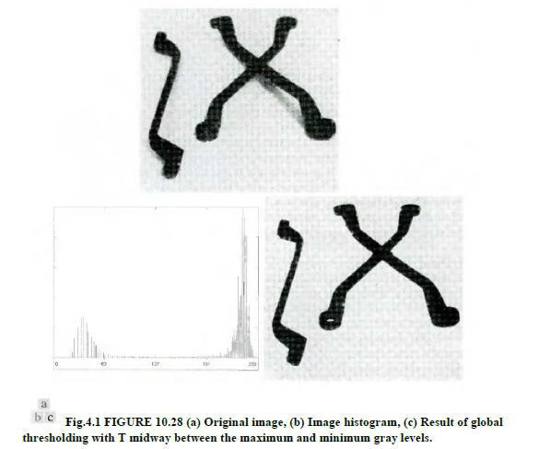

* Figure 4.1(a) shows a simple image, and Fig. 4.1(b) shows its histogram. Figure 4.1(c) shows the result of segmenting Fig. 4.1(a) by using a threshold T midway between the maximum and minimum gray levels. This threshold achieved a "clean" segmentation by eliminating the shadows and leaving only the objects themselves. The objects of interest in this case are darker than the background, so any pixel with a gray level ≤ T was labeled black (0), and any pixel with a gray level ≥ T was labeled white (255).The key objective is merely to generate a binary image, so the black-white relationship could be reversed. The type of global thresholding just described can be expected to be successful in highly controlled environments. One of the areas in which this often is possible is in industrial inspection applications, where control of the illumination usually is feasible.
* The threshold in the preceding example was specified by using a heuristic approach, based on visual inspection of the histogram. The following algorithm can be used to obtain T automatically:

1. Select an initial estimate for T.
2. Segment the image using T. This will produce two groups of pixels: G1 consisting of all pixels with gray level values >T and G2 consisting of pixels with values < T.
3. Compute the average gray level values μ1 and μ2 for the pixels in

regions G1 and G2.

1. Compute a new threshold value:

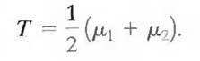

1. Repeat steps 2 through 4 until the difference in T in successive iterations is smaller than a predefined parameter To.

* When there is reason to believe that the background and object occupy comparable areas in the image, a good initial value for T is the average gray level of the image. When objects are small compared to the area occupied by the background (or vice versa), then one group of pixels will dominate the histogram and the average gray level is not as good an initial choice. A more appropriate initial value for T in cases such as this is a value midway between the maximum and minimum gray levels. The parameter To is used to stop the algorithm after changes become small in terms of this parameter. This is used when speed of iteration is an important issue.

**Basic Adaptive Thresholding:**

* Imaging factors such as uneven illumination can transform a perfectly segmentable histogram into a histogram that cannot be partitioned effectively by a single global threshold. An approach for handling such a situation is to divide the original image into subimages and then utilize a different threshold to segment each subimage. The key issues in this approach are how to subdivide the image and how to estimate the threshold for each resulting subimage. Since the threshold used for each pixel depends on the location of the pixel in terms of the subimages, this type of thresholding is adaptive.

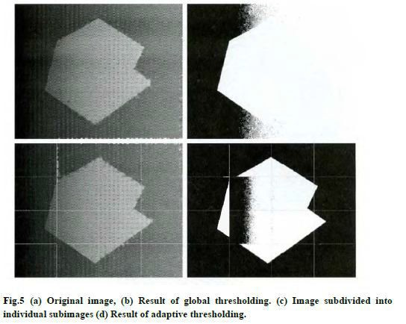

* We illustrate adaptive thresholding with a example. Figure 5(a) shows the image, which we concluded could not be thresholded effectively with a single global threshold. In fact, Fig. 5(b) shows the result of thresholding the image with a global threshold manually placed in the valley of its histogram. One approach to reduce the effect of non uniform illumination is to subdivide the image into smaller sub images, such that the illumination of each subimage is approximately uniform. Figure 5(c) shows such a partition, obtained by subdividing the image into four equal parts, and then subdividing each part by four again. All the sub images that did not contain a boundary between object and back-ground had variances of less than 75. All sub images containing boundaries had variances in excess of 100. Each sub image with variance greater than 100 was segmented with a threshold computed for that sub image using the algorithm. The initial value for T in each case was selected as the point midway between the minimum and maximum gray levels in the sub image. All sub images with variance less than 100 were treated as one composite image, which was segmented using a single threshold estimated using the same algorithm. The result of segmentation using this procedure is shown in Fig. 5(d).
* With the exception of two sub images, the improvement over Fig. 5(b) is evident. The boundary between object and background in each of the improperly segmented sub images was small and dark, and the resulting histogram was almost unimodal.

**Use of Boundary Characteristics for Histogram Improvement and Local Thresholding:**

* It is intuitively evident that the chances of selecting a "good" threshold are enhanced considerably if the histogram peaks are tall, narrow, symmetric, and separated by deep valleys. One approach for improving the shape of histograms is to consider only those pixels that lie on or near the edges between objects and the background. An immediate and obvious improvement is that histograms would be less dependent on the relative sizes of objects and the background.
* For instance, the histogram of an image composed of a small object on a large background area (or vice versa) would be dominated by a large peak because of the high concentration of one type of pixels.
* If only the pixels on or near the edge between object and the background were used, the resulting histogram would have peaks of approximately the same height. In addition, the probability that any of those given pixels lies on an object would be approximately equal to the probability that it lies on the back-ground, thus improving the symmetry of the histogram peaks. Finally, as indicated in the following paragraph, using pixels that satisfy some simple measures based on gradient and Laplacian operators has a tendency to deepen the valley between histogram peaks.
* The principal problem with the approach just discussed is the implicit assumption that the edges between objects and background arc known. This information clearly is not available during segmentation, as finding

a division between objects and background is precisely what segmentation is all about. However, an indication of whether a pixel is on an edge may be obtained by computing its gradient. In addition, use of the Laplacian can yield information regarding whether a given pixel lies on the dark or light side of an edge. The average value of the Laplacian is 0 at the transition of an edge, so in practice the valleys of histograms formed from the pixels selected by a gradient/Laplacian criterion can be expected to be sparsely populated. This property produces the highly desirable deep valleys.

* The gradient at any point (x, y) in an image can be found. Similarly, the Laplacian can also be found. These two quantities may be used to form a three-level image, as follows:



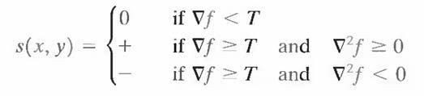

* Where the symbols 0, +, and - represent any three distinct gray levels, T is a threshold, and the gradient and Laplacian are computed at every point (x, y). For a dark object on a light background, the use of the Eqn. produces an image s(x, y) in which (1) all pixels that are not on an edge (as determined by  being less than T) are labeled 0; (2) all pixels on the dark side of an edge are labeled +; and (3) all pixels on the light side of an edge are labeled -. The symbols + and - in Eq. above are reversed for a light object on a dark background. Figure 6.1 shows the labeling produced by Eq. for an image of a dark, underlined stroke written on a light background.
* The information obtained with this procedure can be used to generate a segmented, binary image in which l's correspond to objects of interest and 0's correspond to the background. The transition (along a horizontal or vertical scan line) from a light background to a dark object must be characterized by the occurrence of a - followed by a + in s (x, y). The interior of the object is composed of pixels that are labeled either 0 or +. Finally, the transition from the object back to the background is characterized by the occurrence of a + followed by a -. Thus a horizontal or vertical scan line containing a section of an object has the following structure:



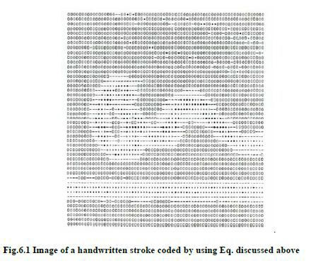

* Where (…) represents any combination of +, -, and 0. The innermost parentheses contain object points and are labeled 1. All other pixels along the same scan line are labeled 0, with the exception of any other sequence of (- or +) bounded by (-, +) and (+, -).

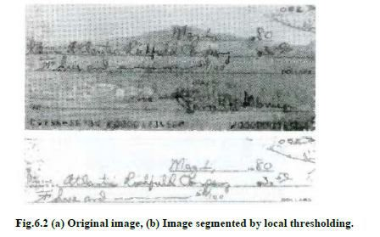

* Figure 6.2 (a) shows an image of an ordinary scenic bank check. Figure

6.3 shows the histogram as a function of gradient values for pixels with gradients greater than 5. Note that this histogram has two dominant modes that are symmetric, nearly of the same height, and arc separated by a distinct valley. Finally, Fig. 6.2(b) shows the segmented image obtained by with T at or near the midpoint of the valley. Note that this example is an illustration of local thresholding, because the value of T was determined from a histogram of the gradient and Laplacian, which are local properties.

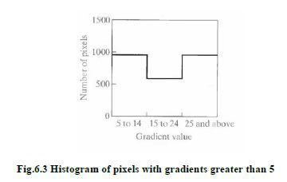

* + 1. **Region-Based Segmentation**
* The objective of segmentation is to partition an image into regions. We approached this problem by finding boundaries between regions based on discontinuities in gray levels, whereas segmentation was accomplished via thresholds based on the distribution of pixel properties, such as gray-level values or color.

**Basic Formulation:**

* Let R represent the entire image region. We may view segmentation as a process that partitions R into n sub regions, R1, R2..., Rn, such that



* Here, P (Ri) is a logical predicate defined over the points in set Ri and Ǿ`

is the null set. Condition

* (a) Indicates that the segmentation must be complete; that is, every pixel must be in a region. Condition
* (b) Requires that points in a region must be connected in some predefined sense. Condition
* (c) Indicates that the regions must be disjoint. Condition
* (d) Deals with the properties that must be satisfied by the pixels in a segmented region—for example P (Ri) = TRUE if all pixels in Ri, have the same gray level.
* Finally, condition (e) indicates that regions Ri and Rj are different in the sense of predicate P.

**Region Growing:**

* As its name implies, **region growing** is a procedure that groups pixels or sub regions into larger regions based on predefined criteria. The basic approach is to start with a set of "seed" points and from these grow regions by appending to each seed those neighbouring pixels that have roperties similar to the seed (such as specific ranges of gray level or color). When a priori information is not available, the procedure is to compute at every pixel the same set of properties that ultimately will be used to assign pixels to regions during the growing process. If the result of these computations shows clusters of values, the pixels whose properties place them near the centroid of these clusters can be used as seeds.
* The selection of similarity criteria depends not only on the problem under consideration, but also on the type of image data available. For example, the analysis of land-use satellite imagery depends heavily on the use of color. This problem would be significantly more difficult, or even impossible, to handle without the inherent information available in color images. When the images are monochrome, region analysis must be carried out with a set of descriptors based on gray levels and spatial properties (such as moments or texture).
* Basically, growing a region should stop when no more pixels satisfy the criteria for inclusion in that region. Criteria such as gray level, texture, and color, are local in nature and do not take into account the "history" of region growth. Additional criteria that increase the power of a region growing algorithm utilize the concept of size, likeness between a candidate pixel and the pixels grown so far (such as a comparison of the

gray level of a candidate and the average gray level of the grown region), and the shape of the region being grown. The use of these types of descriptors is based on the assumption that a model of expected results is at least partially available.

* In following Figure (a) shows an X-ray image of a weld (the horizontal dark region) containing several cracks and porosities (the bright, white streaks running horizontally through the middle of the image). We wish to use region growing to segment the regions of the weld failures. These segmented features could be used for inspection, for inclusion in a database of historical studies, for controlling an automated welding system, and for other numerous applications.

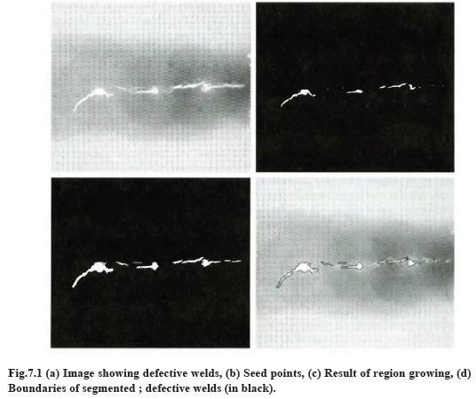

* The first order of business is to determine the initial seed points. In this application, it is known that pixels of defective welds tend to have the maximum allowable digital value 255 in this case. Based on this information, we selected as starting points all pixels having values of

255. Note that many of the points are clustered into **seed regions**.

* The next step is to choose criteria for region growing. In this particular example we chose two criteria for a pixel to be annexed to a region: (1) the absolute gray-level difference between any pixel and the seed had to be less than 65. This number is based on the histogram shown in Fig.

7.2 and represents the difference between 255 and the location of the first major valley to the left, which is representative of the highest gray level value in the dark weld region. (2) To be included in one of the regions, the pixel had to be 8-connected to at least one pixel in that region.

* If a pixel was found to be connected to more than one region, the regions were merged. Figure 7.1 (c) shows the regions that resulted by starting with the seeds in Fig. 7.2 (b) and utilizing the criteria defined in the

previous paragraph. Superimposing the boundaries of these regions on the original image [Fig. 7.1(d)] reveals that the region-growing procedure did indeed segment the defective welds with an acceptable degree of accuracy. It is of interest to note that it was not necessary to specify any stopping rules in this case because the criteria for region growing were sufficient to isolate the features of interest.

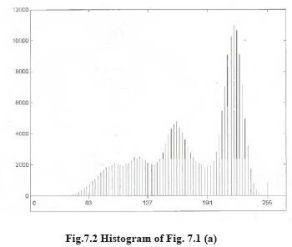

**Region Splitting and Merging:**

* The procedure just discussed grows regions from a set of seed points. An alternative is to subdivide an image initially into a set of arbitrary, disjointed regions and then merge and/or split the regions in an attempt to satisfy the conditions. A split and merge algorithm that iteratively works toward satisfying these constraints is developed.
* Let R represent the entire image region and select a predicate P. One approach for segmenting R is to subdivide it successively into smaller and smaller quadrant regions so that, for any region Ri, P(Ri) = TRUE. We start with the entire region. If P(R) = FALSE, we divide the image into quadrants. If P is FALSE for any quadrant, we subdivide that quadrant into sub quadrants, and so on. This particular splitting technique has a convenient representation in the form of a so-called quadtree (that is, a tree in which nodes have exactly four descendants), as illustrated in Fig.
  1. Note that the root of the tree corresponds to the entire image and that each node corresponds to a subdivision. In this case, only R4 was subdivided further.

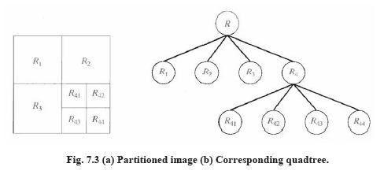

* If only splitting were used, the final partition likely would contain adjacent regions with identical properties. This drawback may be remedied by allowing merging, as well as splitting. Satisfying the constraints, requires merging only adjacent regions whose combined pixels satisfy the predicate P. That is, two adjacent regions Rj and Rk are merged only if P (Rj U Rk) = TRUE.
* The preceding discussion may be summarized by the following procedure, in which, at any step we
  + 1. Split into four disjoint quadrants any region Ri, for which P (Ri) = FALSE.
    2. Merge any adjacent regions Rj and Rk for which P (Rj U Rk) = TRUE.
    3. Stop when no further merging or splitting is possible.
* Several variations of the preceding basic theme are possible. For example, one possibility is to split the image initially into a set of blocks. Further splitting is carried out as described previously, but merging is initially limited to groups of four blocks that are descendants in the quadtree representation and that satisfy the predicate P. When no further mergings of this type are possible, the procedure is terminated by one final merging of regions satisfying step 2. At this point, the merged regions may be of different sizes. The principal advantage of this approach is that it uses the same quadtree for splitting and merging, until the final merging step.

**UNIT-VI**

**Assignment-Cum-Tutorial Questions Section - A**

***Objective***

**5.3 Detection of Discontinuous, edge linking and boundary detection**

1. For line detection we use mask that is [CO-3 BL-2]

A) Gaussian B)Laplacian C) ideal D) Butterworth

1. If inner region of object is textured then approach we use is [CO-3 BL-2]
   1. Discontinuity c. similarity
   2. Extraction d. recognition
2. To avoid negative values taking absolute values in Laplacian image doubles

[CO-3 BL-2]

* 1. thickness of lines c. thinness of lines
  2. thickness of edges d. thinness of edges

1. Second derivative approximation says that values along ramp must be

|  |  |  |  |
| --- | --- | --- | --- |
| a. nonzero | [CO-3 BL-3]  ] | | |
| b. zero |  |  |
| c. positive |  |  |
| d. negative  5. Gradient magnitude images are more useful in | [CO-3 BL-2]  ] | |

* 1. point detection c. line detection
  2. area detection d. edge detection

6. In Laplacian images light shades of gray level is represented by [CO-3 BL-2]

|  |  |  |  |
| --- | --- | --- | --- |
| a. 0 b. 1 | c. positive d. negative |  | |
| 7. For edge detection we use |  | [CO-3 BL-2] | |
| 1. first derivative 2. third derivative | 1. second derivative 2. Both A and C |  |  |

1. Sobel gradient is not that good for detection of [CO-3 BL-3]
   1. horizontal lines c. vertical lines
   2. Diagonal lines d. edges
2. Response of derivative mask is zero at [CO-3 BL-3]
   1. sharp intensities c. constant intensities
   2. low intensities d. high intensities
3. Point detection is done using filter that is [CO-3 BL-2]
4. Gaussian b. Laplacian c. ideal d. Butterworth

**5.4 Thresholding and Region-based segmentation**

1. ___________ is a procedure that groups pixels or sub regions What is the choose criteria for region growing for a pixel to be annexed to a region.

[CO-3 BL-2]

A) The absolute gray-level difference between any pixel and the seed had to be less than some threshold

1. To be included in one of the regions, the pixel had to be 8-connected to at least one pixel in that region.
2. Both d. none
3. Sobel is better than prewitt in image [CO-3 BL-3]
4. Sharpening c. blurring
5. Smoothing d. contrast
6. Intensity's local changes can be detected through [CO-3 BL-2]
7. Differentiation b. derivation c. addition d. integration

**Descriptive:**

**5.3 Detection of Discontinuous, edge linking and boundary detection**

* 1. Explain the method for point detection. [CO-3 BL-2]
  2. Explain the method for line detection. [CO-3 BL-2]
  3. Explain the method for edge detection. [CO-3 BL-2]
  4. What are the derivative operators useful in image segmentation? Explain their role in segmentation. [CO-3 BL-2]
  5. Explain about the edge linking procedures. [CO-3 BL-2]

**5.4 Thresholding and Region-based segmentation**

* 1. What is thresholding? Explain about global thresholding. [CO-3 BL-2]
  2. Explain about basic adaptive thresholding process used in image segmentation. [CO-3 BL-2]
  3. Explain in detail the threshold selection based on boundary characteristics. [CO-3 BL-3]
  4. Explain Region Growing in region based segmentation. [CO-3 BL-2]
  5. Explain about Region splitting and merging in region based segmentation. [CO-3 BL-2]